LAT 1120 Beginning Latin 1
Section: 10001 Spring 2026


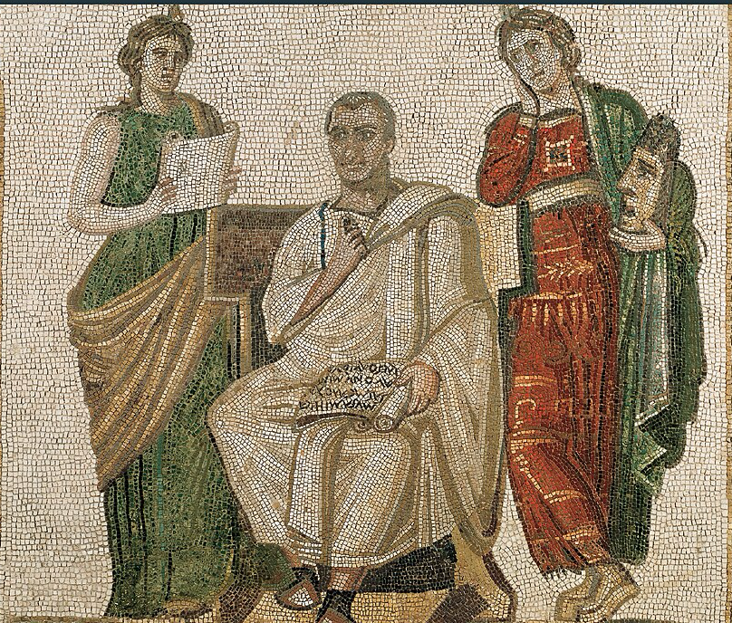
Image: Wheelock’s Latin, 7th ed., cover image. Used for educational purposes.

Time and Location
MWF Period 5 (11:45 - 12:35)
AH 0213 (https://campusmap.ufl.edu/#/index/0268)

Contact Information
Achilles Valetopoulos
a.valetopoulos@ufl.edu

Office Hours: M 3:00-3:50 PM; F 1:55-2:45 PM, and by appointment

Department Phone: (352) 392-2075
125Ε Dauer Hall

[Note: The best way to come in contact with the instructor is via e-mail. For inquiries regarding the course, please make use of Canvas inbox; for other issues, please feel free to contact through the Gator e-mail]

Course Description

This course is the first of a three-part Beginning Latin sequence at the University of Florida. The course covers chapters 1-14 of Wheelock’s Latin and is designed to introduce students to the fundamental vocabulary, grammar, and syntax of classical Latin. Students will practice translation both from Latin to English and from English to Latin. Additionally, students will practice reading passages of continuous Latin derived and adapted from real works by ancient authors. Students will leave this class prepared to succeed in Latin 2.

Course Objectives

Students will learn the inflectional patterns of the Latin language and develop the ability to recognize and translate the forms of various declensions and conjugations. Beginning with the first class meeting, students will build a rich vocabulary which will assist students in becoming familiar with the grammatical structures of the Latin language and serve as an introduction to Roman culture.

Credits

The course is worth 4 credits.

Prerequisites

No prior knowledge of Latin language is required for this course.

Activities

- Written exercises completed both in class and as homework
- In-class group reading
- Oral drills and recitation focused on proper pronunciation
- 10 vocabulary quizzes, 3 midterm exams, and a final exam

Textbooks

- Wheelock, Frederick M. and R. A. LaFleur, Wheelock’s Latin. 2011. ISBN-10: 0061997226 [Required]
- Groton, Anne H. and James M. May, Thirty-Eight Latin Stories. 2004. ISBN-10: 0865162891 [Optional]
- Goldman, Ladislas and Norma Szymanski, English Grammar for Students of Latin : The Study Guide for Those Learning Latin. 1983. ISBN-10‏: ‎0934034192
[Optional]
Students are also expected to have a notebook for use in class and for completing homework.

Policies

Attendance: Attendance is mandatory. Students are permitted three (3) unexcused absences. For each unexcused absence beyond the third, one point will be deducted from the final course grade.

- For absences approved in accordance with university policy—such as participation in an official university activity, observance of a religious holiday, performance of military duty, or other approved conflicts (e.g., jury duty)—that the student knows about in advance, the student is required to notify the instructor before the assignment is due, and, if possible, at the start of the semester. The sooner you inform of an expected absence, the easier it is to accommodate.

Make-Up Policy: For make-up and/or late work, appropriate documentation is required. You may receive an extension on an assignment only if the request for the extension is prompt, timely, and accompanied by all necessary written documentation.

Requirements for class attendance and make-up exams, assignments, and other work in this course are consistent with university policies that can be found at https://catalog.ufl.edu/UGRD/academic-regulations/attendance-policies/.

General Expectations: Students are expected to actively participate during class, both by answering questions and engaging in group activities. Students must be respectful when a fellow student or the instructor is speaking. In order to foster productive participation, cell phone use is prohibited during class, and eating or drinking should be kept to a minimum. Laptops used for note-taking are permitted so long as they are used appropriately. The majority of course materials and assignments will be posted to Canvas as well.

Classroom Accommodations: Students with disabilities who experience learning barriers and would like to request academic accommodations should connect with the Disability Resource Center (https://disability.ufl.edu/get-started/). It is important for students to share their accommodation letter with their instructor and discuss their access needs as early as possible in the semester. Academic accommodations must be arranged and administered through the Disability Resource Center (DRC), rather than by individual instructors.

Course Evaluation: Students are expected to provide professional and respectful feedback on the quality of instruction in this course by completing course evaluations online via GatorEvals. Guidance on how to give feedback in a professional and respectful manner is available at https://gatorevals.aa.ufl.edu/students/. Students will be notified when the evaluation period opens and can complete evaluations through the e-mail they receive from GatorEvals in their Canvas course menu under GatorEvals or via https://ufl.bluera.com/ufl/. Summaries of course evaluation results are available to students at https://gatorevals.aa.ufl.edu/public-results/.

University Honesty Policy: UF students are bound by The Honor Pledge which states: “We, the members of the University of Florida community, pledge to hold ourselves and our peers to the highest standards of honor and integrity by abiding by the Honor Code. On all work submitted for credit by students at the University of Florida, the following pledge is either required or implied: ‘On my honor, I have neither given nor received unauthorized aid in doing this assignment.’” The Honor Code (https://policy.ufl.edu/regulation/4-040/#A1) specifies a number of behaviors that are in violation of this code and the possible sanctions. Furthermore, you are obligated to report any condition that facilitates academic misconduct to appropriate personnel. If you have any questions or concerns, please consult with the instructor or TAs in this class.

Evaluation of Grades

ASSIGNMENT | PERCENTAGE OF FINAL
Homework | 15%
Attendance/Participation | 15%
Individual Project  (+ Project Proposal) | 15%
Weekly Vocab Quizzes (10 total; 1 dropped) | 20%
Midterm Exams 1, 2 & 3 | 20%
Final Exam | 15%

Grading Scale

POINTS | LETTER GRADE | GPA POINTS
93.0 – 100.0 | A | 4.00
90.0 – 92.9 | A- | 3.67
87.0 – 89.9 | B+ | 3.33
83.0 – 86.9 | B | 3.00
79.0 – 82.9 | B- | 2.67
75.0 – 78.9 | C+ | 2.33
72.0 – 74.9 | C | 2.00
69.0 – 71.9 | C- | 1.67
66.0 – 68.9 | D+ | 1.33
62.0 – 65.9 | D | 1.00
60.0 – 61.9 | D- | 0.67
0.0 – 59.9 | E | 0.00

*NB: An earned grade of ‘C-’ will not be a qualifying grade for major, minor, Gen. Ed., or basic distribution credit.

Information on current UF policies for assigning grade points can be found here: https://catalog.ufl.edu/UGRD/academic-regulations/grades-grading-policies/.

Course Schedule

The schedule is tentative and may change, but all exam dates are fixed.
WEEK | TOPICS
1  [class 1] January 12 (M)  [class 2] January 14 (W)  [class 3] January 16 (F) | Introduction; Verbs – First and Second Conjugations (laudo and moneo): Indicative, Imperative, and Infinitive
2  [NO CLASS] January 19 (M)  [class 4] January 21 (W)  [class 5] January 23 (F) | **(01/19) Martin Luther King, Jr. Day  Vocab Quiz 1  Nouns and Cases – First Declension; Agreement of Adjectives
3  [class 6] January 26 (M)  [class 7] January 28 (W)  [class 8] January 30 (F) | Vocab Quiz 2  Second Declension: Masculine Nouns and Adjectives; Apposition; Word Order; Neuters of the Second Declension; Summary of Adjectives;
4  [class 9] February 2 (M)  [class 10] February 4 (W)  [class 11] February 6 (F) | Vocab Quiz 3  Present Indicative of Sum; Predicate Nouns and Adjectives; Substantives; Adjectives in -er; First and Second Conjugations: Future and Imperfect;
5  [class 12] February 9 (M)  [class 13] February 11 (W)  [class 14] February 13 (F) | Exam 1 (Weeks 1-4)  Sum: Future and Imperfect Indicative; Possum: Present, Future, and Imperfect Indicative;
6  [class 15] February 16 (M)  [class 16] February 18 (W)  [class 17] February 20 (F) | Vocab Quiz 4  Third Declension Nouns; Complementary Infinitive
7  [class 18] February 23 (M)  [class 19] February 25 (W)  [class 20] February 27 (F) | Vocab Quiz 5  Third Conjugation (ago): Present Infinitive, Present, Future, and Imperfect Indicative, Present Imperative
8  [class 21] March 2 (M)  [class 22] March 4 (W)  [class 23] March 6 (F) | Vocab Quiz 6  Demonstrative Pronouns: Hic, Ille, Iste; Special –ius adjectives
9.  [class 24] March 9 (M)  [class 25] March 11 (W)  [class 26] March 13 (F) | Vocab Quiz 7  Fourth Conjugation and Third -io Verbs: Present, Imperfect and Future Indicative, Present Imperative, and Active Infinitive
10 NO CLASS (SPRING BREAK)
March 16 (M)
March 18 (W)
March 20 (F)
11  [class 27] March 23 (M)  [class 28] March 25 (W)*  [class 29] March 27 (F) | Exam 2 (Weeks 5-9)  Personal Pronouns Ego, Tu, and Is; Demonstratives Is and Idem  *INDIVIDUAL PROJECT PROPOSAL DUE 03/25 11:59PM
12  [class 30] March 30 (M)  [class 31] April 1 (W)  [class 32] April 3 (F) | Vocab Quiz 8  Perfect Active System of All Verbs; Principal Parts
13  [class 33] April 6 (M)  [class 34] April 8 (W)*  [class 35] April 10 (F) | Vocab Quiz 9  Reflexive Pronouns and Possessives; The Intensive Pronoun ‘Ipse’  *INDIVIDUAL PROJECT DUE 04/08 11:59PM
14  [class 36] April 13 (M)  [class 37] April 15 (W)  [class 38] April 17 (F) | Exam 3 (Weeks 11-13)  I-Stem Nouns of the Third Declension
15  [class 39] April 20 (M)  [class 40] April 22 (W)  [NO CLASS] April 24 (F)** | Vocab Quiz 10  Ablatives of Means, Manner, and Accompaniment; REVIEW  **Reading Day
16  [Final Exam] April 29 (W) | IN-PERSON FINAL EXAM  (04/29)  10 AM – 12 PM
Assessments will take place in class. Excluding the first vocabulary quiz (and final exam), all assessments will be given on the Monday of their respective weeks.

Important dates

01/21 Vocab Quiz 1
01/26 Vocab Quiz 2
02/02 Vocab Quiz 3
02/09 Exam 1
02/16 Vocab Quiz 4
02/23 Vocab Quiz 5
03/02 Vocab Quiz 6
03/09 Vocab Quiz 7
03/23 Exam 2
03/25 Individual Project Proposal due (11:59PM)
03/30 Vocab Quiz 8
04/06 Vocab Quiz 9
04/08 Individual Project due (11:59PM)
04/13 Exam 3
04/20 Vocab Quiz 10
04/29 In-person Final Exam 10 AM – 12 PM

Campus Resources
This course complies with all UF academic policies. For information on those policies and for resources for students, please see this link.

Health and Wellness

U Matter, We Care:
If you or a friend is in distress, please contact umatter@ufl.edu or call (352) 392-1575 so that a team member can reach out to the student.

Counseling and Wellness Center: Visit http://www.counseling.ufl.edu/cwc, or call (352) 392-1575 or the University Police Department at (352) 392-1111—Call 911 for emergencies.

Sexual Assault Recovery Services (SARS)
For the Student Health Care Center, call (352) 392-1161.

University Police Department
Call (352) 392-1111 (or 911 for emergencies), or visit http://www.police.ufl.edu/.
Academic Resources

E-Learning Technical Support
Call (352) 392-4357, select option 2, or e-mail Learning-support@ufl.edu. Visit https://elearning.ufl.edu/student-help/.

Career Resource Center
Visit Reitz Union, or call (352) 392-1601. Reach out for career assistance and counseling. Also, visit https://career.ufl.edu/.

Library Support
Visit http://cms.uflib.ufl.edu/ask. Reach out for various ways to receive assistance with respect to using the libraries or finding resources.

Teaching Center
Visit Broward Hall, or call (352) 392-2010 or (352) 392-6420. Reach out for general study skills and tutoring. Also, visit https://teachingcenter.ufl.edu/.

Writing Studio
Visit Tigert Hall 302, or call (352) 846-1138. Reach out for help with brainstorming, formatting, and writing papers. Also, visit https://writing.ufl.edu/writing-studio/.

Student Complaints Campus
Visit https://www.dso.ufl.edu/documents/UF_Complaints_policy.pdf.

On-Line Students Complaints
Visit http://www.distance.ufl.edu/student-complaint-process.

Student Health Care Center
Call 352-392-1161 for 24/7 information to help you find the care you need, or visit the Student Health Care Center website: https://shcc.ufl.edu/

UF Health Shands Emergency Room / Trauma Center
For immediate medical care call 352-733-0111 or go to the emergency room at 1515 SW Archer Road, Gainesville, FL 32608; Visit the UF Health Emergency Room and Trauma Center website: https://ufhealth.org/locations/uf-health-shands-emergency-room-trauma-center/

GatorWell Health Promotion Services
For prevention services focused on optimal wellbeing, including Wellness Coaching for Academic Success, visit the GatorWell website (https://gatorwell.ufsa.ufl.edu/) or call 352-273-4450.

